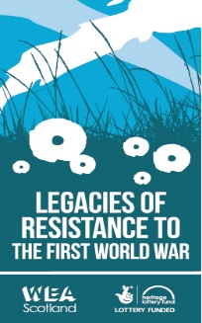
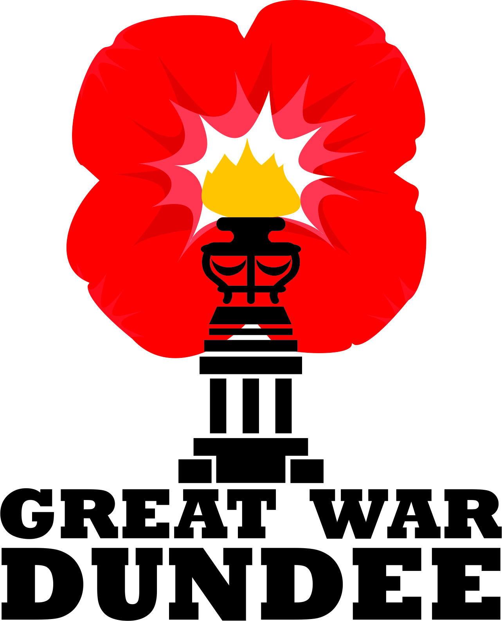

Great War Dundee
&
WEA Scotland Legacies of Resistance to the First World War

Marking Conscientious Objectors Awareness Week in Dundee

With A Series of Free Public Engagement Events
May 18 to May 19, 2018

------------------------------------------------
In Association and Partnership with

Abertay Historical Society

Centre for Scottish Culture, University of Dundee

Commemoration, Conflict and Conscience
(A festival of hidden histories of WW1) University of Bristol Law School

Edinburgh peace and Justice centre

Everyday Lives in War Engagement Centre

Gateways to the First World War Engagement Centre

Workers Education Association Scotland
------------------------------------------------
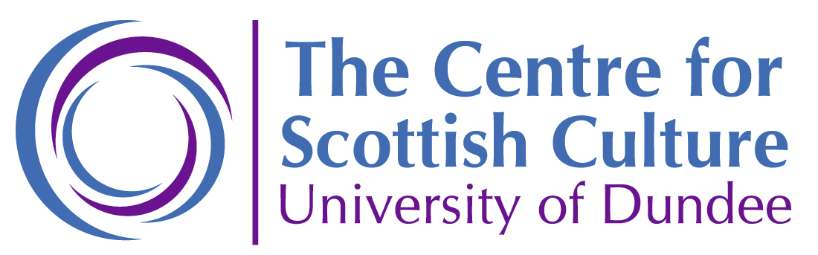
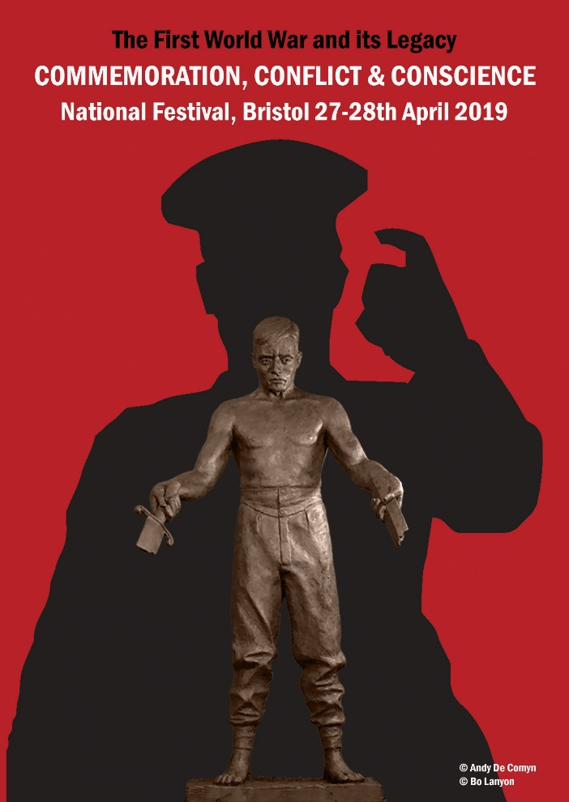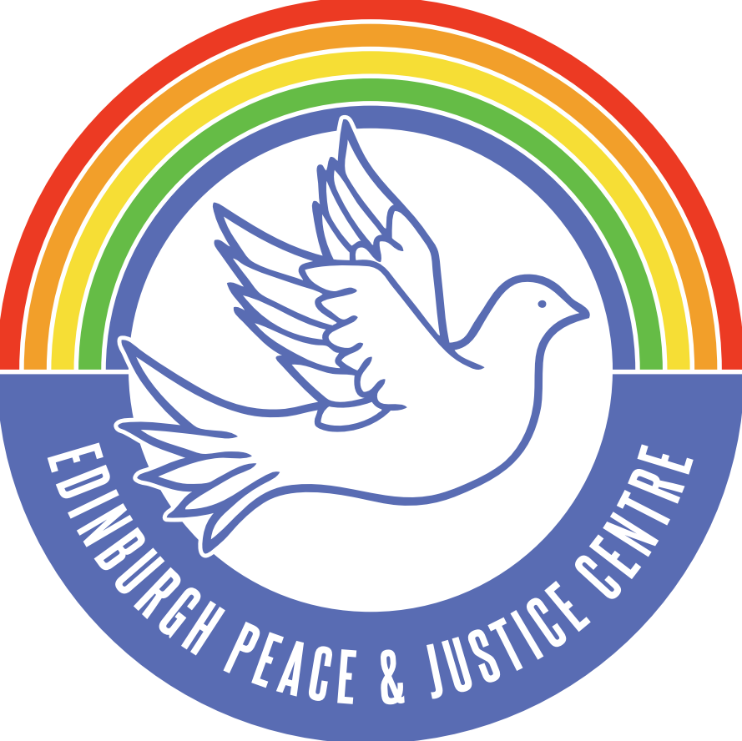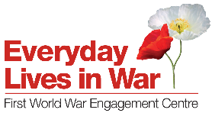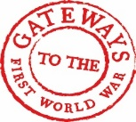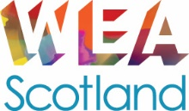

Abertay Historical Society & Great War Dundee
Evening Lecture
Dalhousie Building, Lecture Theatre 1, University of Dundee
Friday 18 May – 6.30 to 20.15 (lecture starts 7.00 pm prompt)

This is a free event and tickets are available through Eventbright
https://www.eventbrite.co.uk/e/abertay-historical-society-great-war-dundee-evening-lecture-tickets-44752447776?utm_term=eventurl_text

Cyril Pearce
‘Communities of Resistance: Some new thoughts on British War Resisters 1914-1918'. British Conscientious Objection at the time of the First World War
Sponsored jointly by: Commemoration, Conflict and Conscience Project, Everyday Lives in War Engagement Centre and Gateways to the First World War Engagement Centre
A stall and table will also be set up by the Commemoration, Conflict and Conscience 2019 (a year-long project culminating in a National Festival, Bristol 27-29 April 2019) project team. It will be open between 6.00 pm until 9.0. It will remain in place until 4.30 after the close of the Conscientious Objectors Awareness Day Event, Dundee, on Saturday May 19, 2018.

The project team will be happy to take questions and enquiries before and after the main event on Friday. Cyril Pearce is a member of the Advisory Board of the project.
------------------------------------------------

About the Project
‘Commemoration, Conflict and Conscience’
Focuses on work undertaken around the UK by community groups but will also include talks, film, theatre, exhibitions, art, academics, poets, puppets, music, song and dance. UK festival of hidden stories of WW1: Commemoration, Conflict and Conscience 2019, Bristol
The main festival will take place 27-28 April 2019, with linked events taking place in the city of Bristol in the weeks coming up to and following that weekend. The histories highlighted may include: conscientious objectors; executions; the Shot at Dawn campaign; the women's peace crusade; the Hague Congress of 1915; war resistance; desertion and absenteeism; the global reach of the war; colonial and commonwealth experiences; mutinies; strikes.
------------------------------------------------
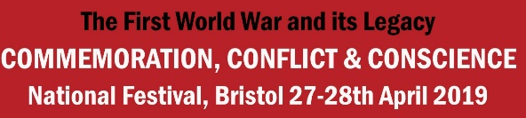

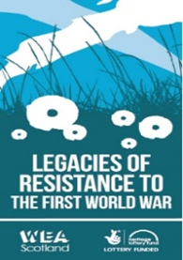

Conscientious Objectors Awareness Day Event Dundee
Saturday 10.30-3.00 May 19, 2018
Dalhousie Building, Room 1LG03, University of Dundee

War, Conscription and Conscientious Objection 1914-1919

A Free Event - including refreshments and light buffet lunch - tickets booked Eventbright
https://www.eventbrite.co.uk/e/war-conscription-and-conscientious-objection-1914-1919-tickets-44752516983?aff=erelpanelorg

Session 1 - Organised by Great War Dundee

10.00 to 10.30 Refreshments and Register (this is a free event,
10.30 to 10.40 Welcome
Derek Patrick - Great War Dundee and University of St Andrews

10.40 to 11.00 Commemoration, Conflict and Conscience in Context
Cyril Pearce - Commemoration, Conflict and Conscience 2019, Bristol University School of Law (UK festival of hidden stories of WW1)

11.00 to 11.30 What would you do?
Audience participation and survey (organised by Kait Laughlin WEA):
your views and thoughts on Conscription, Conscientious Objection, and Conscientious Objectors? (Second survey follows in afternoon Session 2)

Comfort Break - 11.30 to 11.40 (prompt)

11.40 to 12.10 Dundee Case study - A Tale of Two Brothers:
Ewan Geddes Carr (Socialist and War Resister) and William Stewart Carr (Socialist and Soldier)
Billy Kenefick and Bill Carr – Great War Dundee

12.10 to 12.30 Session 1 – Panel and Audience Q&A
Buffet Lunch and Refreshments – 12.30 to 1.00

Conscientious Objectors Awareness Day Event Dundee
Saturday 10.30-3.00 May 19, 2018

War, Conscription and Conscientious Objection 1914-1919

Session 2

Organised by
Workers Education Association Scotland
Legacies of Resistance to the First World War

1.00 to 3.00

Session introduced by Kait Laughlin Project Leader for Legacies of Resistance to the First World War. Followed by presentation from Dundee, Edinburgh and Glasgow Project Learner Groups, second survey conducted and closing musical event.

3.00 - END of CO Awareness Day Event
------------------------------------------------
Additional Activity - 3.00 to 4.30
Commemoration, Conflict and Conscience 2019 (a UK festival of hidden stories of WW1), Bristol - Stall and Table
The project team will be happy to further questions and enquiries after the close of the main and stall and table will remain open until 4.30.
About the Project
‘Commemoration, Conflict and Conscience’

Focuses on work undertaken around the UK by community groups but will also include talks, film, theatre, exhibitions, art, academics, poets, puppets, music, song and dance. UK festival of hidden stories of WW1: Commemoration, Conflict and Conscience 2019, Bristol

The main festival will take place 27-28 April 2019, with linked events taking place in the city of Bristol in the weeks coming up to and following that weekend. The histories highlighted may include: conscientious objectors; executions; the Shot at Dawn campaign; the women's peace crusade; the Hague Congress of 1915; war resistance; desertion and absenteeism; the global reach of the war; colonial and commonwealth experiences; mutinies; strikes.

