SOPHIST Laboratory Manual V6 19-03-2026
Trial Title | SOPHIST
CI | Dr Ify Mordi
Sponsor | University of Dundee and NHS Tayside
IRAS number | 1007807
Author/Contact | Sophist-trial@dundee.ac.uk
Protocol Version | V6
Associated Documents

Abbreviations / terms used:
BNP | B-type natriuretic peptide
FBC | Full Blood Count
HbA1c | Glycated Haemoglobin
LFT | Liver Function Tests
NT-proBNP | N-terminal pro B-type natriuretic peptide
U&E | Urea and electrolytes

Contents
1. Procedures 2
2. Equipment 2
2.1. Bloods 2
2.2. Urine 2
3. Sample ID 2
4. Samples required 3
5. Research sample collection 4
6. Research sample processing 5
7. Labelling research samples 6
8. Storing research samples 6
9. Shipping research samples from sites to University of Dundee 7
Appendix 1 Obtaining Blood Samples When Monovette Tubes Are Used 8

Procedures
- Ensure all equipment used is within expiry date.
- Obtain blood samples as per local venepuncture Standard Operating Procedure.
- Dispose of all clinical equipment as per local policy.
- Deal with any needlestick injury or body fluid spillage as per local policies.

Equipment

Bloods
- Blood tubes as per visit (research blood tubes are provided).
- Venepuncture equipment (e.g. needles, tourniquet, cotton wool etc.).
- Collection set compatible with vacutainer tubes must be used.
- Centrifuge
- Pipettes
- Microtubes (provided)
- Sample labels (provided).
- Sample Logs (provided).
- Sample storage boxes (provided).
- Freezer (-65 to -80°C).

Urine
- Urine containers (research urine samples containers provided).
- Microtubes (provided)
- Urine pregnancy test kit, if required.
- Freezer (-65 to -80°C).

Sample ID
- Sample ID is made up of:
site number – participant number – visit number – sample number
e.g. sample ID 01-001-02-01 would be site 01 – participant 001- visit 02- sample number 01

Samples required

Visit | Local NHS Labs | Research bloods | Research bloods | Research Urine
Visit | Local NHS Labs | To be collected for participants that did NOT consent for additional samples for future research‡ | To be collected for participants that have provided consent for additional samples for future research‡
1  Screening | Bloods:  - FBC  - U&Es  - LFT  - Glucose  - HbA1c  - NT-proBNP/BNP (If not available within 12 months of screening)  Urine  - Pregnancy test*
3  Baseline | Bloods:  - FBC  - U&Es  - LFT  - Glucose  Urine:  - Albumin  - Creatinine  - Sodium  - Pregnancy test* | 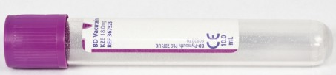  Purple EDTA 4mL tube | 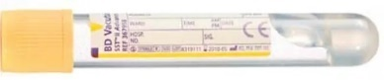  2 x 8.5mL Gold/SST tubes  1 x 3.5mL Gold/SST tube  (Total SST= 20.5mL)  2 x 10mL Purple EDTA tubes  (Total EDTA = 20mL)  § Genetic analysis:  1 x 4mL Purple EDTA tube | Urine universal container  (Total = 20mL)  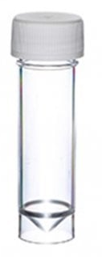
5 | Bloods:  - FBC  - U&Es  - LFT  - Glucose  Urine:  - Albumin  - Creatinine  - Sodium
7 | Bloods:  - FBC  - U&Es  - LFT  - Glucose  - HbA1c  Urine:  - Albumin  - Creatinine  - Sodium | Purple EDTA 4mL tube | 2 x 8.5mL Gold/SST tubes  1 x 3.5mL Gold/SST tube  (Total SST= 20.5mL)  2 x 10mL Purple EDTA tubes  (Total EDTA = 20mL)  § Genetic analysis:  1 x 4mL Purple EDTA tube | Urine universal container (Total = 20mL)
Unscheduled
NHS bloods as clinically indicated
*To be carried out on women of childbearing potential
‡ The research blood and urine samples will be stored frozen and later shipped to Dundee for analysis for trial outcomes and future research.
§ Only to be collected if participant also consented for additional blood sample for future genetic analysis.

Research sample collection
Blood sample collection
Safety blood samples should always be drawn before research bloods but all samples should be taken at the same time with the SST tubes being collected before the EDTA tubes.
Urine sample collection
Ask patient to collect the sample in the middle of passing urine "mid-stream" in the white top universal container. Alternatively, a different clean container can be used in the toilet and the urine should be transferred to the 20mL universal container.

Research sample processing
For participants that did NOT consent for additional samples for future research
TUBES | INVERT TUBE | ALLOW TO STAND | CENTRIFUGE | TRANSFER | LABEL | FREEZE
If the participant has not consented to additional blood samples for research  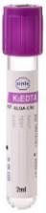  EDTA  4mL | 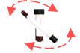  8-10 times |   Stand upright  30 mins | 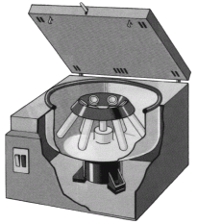  1100 to 1300 xg  for 15 mins | 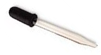    Transfer  1 mL plasma per microtube | 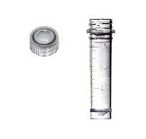As many microtubes as required for available plasma | 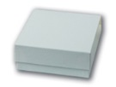  Store upright in Plasma box.  Transfer to  Freezer (-65 to -80°C) within 1 hour of collection.

For participants that have provided consent for additional samples for future research
TUBES | INVERT TUBE | ALLOW TO STAND | CENTRIFUGE | TRANSFER | LABEL | FREEZE
SST  2 x 8.5mL  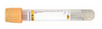  1 x 3.5mL  tubes  Total = 20.5mL | 5 times | Stand upright  30 mins | 1100 to 1300 xg  for 15 mins | Transfer  1 ml serum per microtube | As many microtubes as required for available serum | Store upright in Serum box.  Transfer to  freezer (-65 to -80°C) within 1 hour of collection.
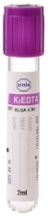  EDTA  2 x 10mL tubes  Total = 20mL | 8-10 times | Stand upright  30 mins | 1100 to 1300 xg  for 15 mins | Transfer  1 mL plasma per microtube | As many microtubes as required for available plasma | Store upright in Plasma box.  Transfer to  freezer (-65 to -80°C) within 1 hour of collection.
EDTA  1 x 4mL tube  Total = 4mL | 8-10 times | N/A |  |  | 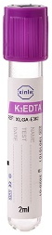 | Store upright in Whole blood box.  Transfer to  freezer (-65 to -80°C) within 1 hour of collection.
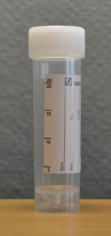  Urine 20mL Universal container. | N/A | Transfer 2mL of urine per microtube |  |  | 5 microtubes | Store upright in Urine box.  Transfer to  freezer (-65 to -80°C) within 1 hour of collection.

Labelling research samples
- All trial samples should be labelled with the labels provided.
SOPHIST Urine 2 ml

Sample ID: _ _ - _ _ _ - _ _ - _ _
Date: _ _ - _ _ - _ _ _ _

SOPHIST Plasma 1 ml

Sample ID: _ _ - _ _ _ - _ _ - _ _
Date: _ _ - _ _ - _ _ _ _

SOPHIST Serum 1 ml

Sample ID: _ _ - _ _ _ - _ _ - _ _
Date: _ _ - _ _ - _ _ _ _

SOPHIST Whole Blood (EDTA)

Sample ID: _ _ - _ _ _ - _ _ - _ _
Date: _ _ - _ _ - _ _ _ _

- The appropriate sample label should be used for whole blood, serum or plasma blood sample or urine sample.
- All microtubes originating from the same vacutainer should be listed together on one row of the sample log.
- Ensure labels are attached prior to freezing. Ensure that the label is firmly rubbed on to the tube/microtube to prevent it coming off.
- Complete each label with full sample ID and date as below. Ensure label is completed prior to freezing and appropriate marker pen is used.
- Date to be filled in day/month/year i.e. 30-03-2024
- All samples should be logged on the appropriate SOPHIST Sample Log.

Storing research samples
- The research samples should be stored in the storage boxes provided within 1 hour of collection.
- Research blood samples should be stored in separate boxes according to sample type.
- The storage boxes should be labelled with trial title, site number, sample type and box number.
- Storage location should be recorded on the SOPHIST Sample Log.

Shipping research samples from sites to University of Dundee
At the end of the trial the Trial Manager, Tayside Clinical Trials Unit, will organise a courier to transport frozen samples on dry ice to University of Dundee research labs.
- Collection will be arranged for Monday-Wednesday to arrive next day.
- All samples must be accompanied by:
  - Completed Sample Log (paper)
  - Completed Sample Shipment Manifest Document (paper)
  - The Sample Log (scanned copy) & Sample Shipment Manifest document (scanned copy) should be emailed to sophist-trial@dundee.ac.uk

Appendix 1 Obtaining Blood Samples When Monovette Tubes Are Used
This applies in sites where the NHS Labs use monovette blood collection tubes.
- The Research Samples MUST be collected in the tubes provided and therefore venepuncture should be carried out using a compatible blood collection system.

Visits 3 and 7  - A vacutainer blood collection system “Butterfly” can be used. | - A vacutainer needle and holder can be used
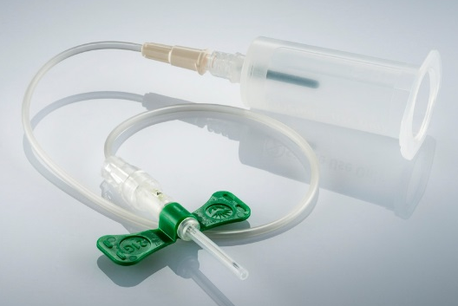 | 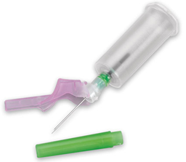

When NHS blood samples are also required and if your lab will only accept monovette tubes then these can be used with the vacutainer system.
- Pre–vacuum the monovette tube by pulling the plunger out.

- Attach to the vacutainer needle as below, fill tube and send to NHS Lab as local practice.
