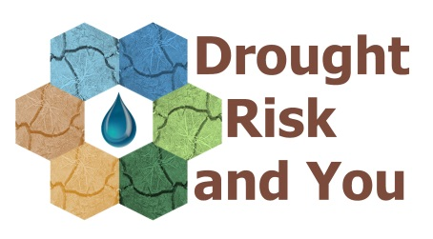
Exploring the impacts of drought on UK crops
Events for farmers and local people interested in the effects of climate change
Saturday 20 January
09.30-11.30 at Lomond Hills Hotel, Freuchie and from 12.00 in the Lomond Hills – meet at Craigmead Car Park
The Drought Risk and You (DRY) Project is taking a pioneering approach to better understand drought by bringing together a unique blend of hydrological and ecological science and stories from different water users to inform drought risk decision-making in Scotland, England and Wales.
Participants: farmers and local people – prior registration required
9.30-10.00: Arrival: tea & coffee; bacon rolls
10.00-10.10: Welcome and introduction to the DRY project: Prof Lindsey McEwen
10.10-10.30 Scene setting: you will have the opportunity to share your memories, experiences and knowledge about droughts and water use and its short-term and long-term impacts (more time will be available for one-to-one interviews later in the day).
10.30-11.30: Dr Ivan Grove (Harper Adams University) will present results of our crop research, with opportunities to discuss implications for Fife. Drought experiements have been conducted on Wheat, Barley, Triticale, Durum Wheat, Quinoa, Perennial Rye Grass and Lucerne.
12.00-13.30: Field trip to mesocosm monitoring site: Led by Dr Andrew Black (Dundee University) and Dr Ivan Grove (Harper Adams University). We will examine the practicalities of exposing vegetation to reduced rainfall, the methods for assessing vegetation response and the results to date. The site is above Craigmead Car Park found at the summit of the hill road between Falkland and Leslie (meet at car park, grid ref NO227061). Stout footwear, warm and waterproof clothing is essential. Terrain is rough and likely wet.
13.30-14.30: Lunch and audio/video interviews – by individual arrangement

Please register for this event via Eventbrite:
To assist with the collection of digital stories, the organisers are interested to arrange opportunities to audio/video record your experiences and insights about drought risk in the Eden catchment. We’ll follow up all registrations with a follow-up email asking (without any obligation) if you would like to make yourself available for this.

