Nordic Web Surveillance Project - Eyes Online
Principal Investigator: Dr Megan O’Neill, University of Dundee
Local Researcher: Amy Humphrey, University of Dundee

Project overview
This project will explore the ways in which various stakeholders, including security professionals, government agencies, and private citizens understand web surveillance and expanded powers for investigation of internet use.
The academic title for this project is:
Taking Surveillance Apart: Accountability and Legitimacy of web surveillance and expanded investigatory powers
Data is being collected across three countries, the UK, Norway and Finland, to inform a comparative analysis to highlight perceptions and rationales which are universal, and those which are geographically or professionally specific.
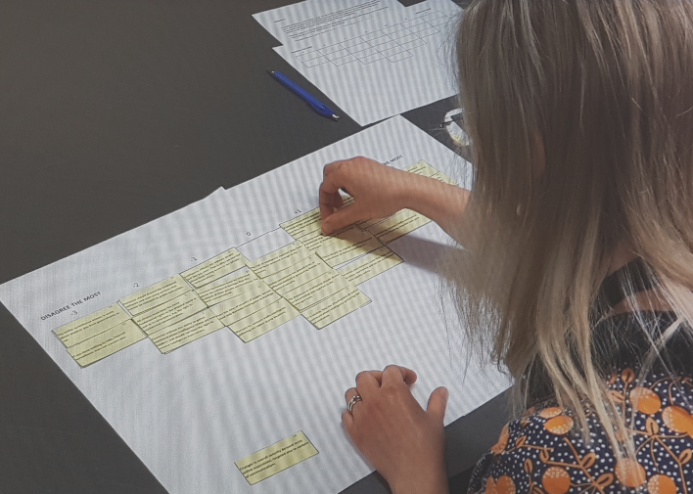
Findings will be used to make recommendations on policy and practice. The work will also be communicated to the public to increase transparency and encourage healthy debate through building shared understandings of the key issues
This study
You have been approached to contribute to one strand of the research, which focusses on how subject matter specialists in particular understand issues such as privacy, surveillance, the need for intelligence and accountability in web surveillance.
1: Photo showing someone completing a Q-Sort exercise

Participants will not be asked for technical details about sensitive tactics.
This will be achieved using an interview style called Q-Method.
Q-Method
A Q-Method interview takes about 1.5 hours. It begins with a practical exercise in which you will be asked to sort a selection of statements pertaining to contemporary debates on web surveillance and expanded investigatory powers.
The interview can be in English, or if you are in Norway or Finland, in Norwegian or Finnish.
The interview will be audio recorded for accuracy purposes. This recording will be transcribed and anonymised. The audio recording will then be destroyed.
Your Interview
The local researcher will agree a time and place convenient to you for the interview.
………………………………………………
………………………………………………
The interview location will need to have a large table at which to do the Q-sort exercise. Your interviewer will discuss requirements when coordinating with you.

Confidentiality and your data
Your participation in this study is voluntary and you can choose to withdraw at any time, up to the point of data anonymization for any reason. This can be done through contacting your local researcher, or the principal investigator. Contact details are at the end of this sheet.
The fully anonymised written transcript of your interview will be held for 10 years after completion of all publications. It will be available for analysis by any member of this research group.
In line with Nordforsk data policy, it will also be made available to other academics through UK Data Archive
All responses will be anonymous. No real names or places of work will be identifiable. Written transcripts will omit any identifying or sensitive information. Demographic information will be kept, but all due care will be taken to ensure inference of identity cannot be made from it.
Interviews in Norwegian and Finnish will be translated by a professional external to the research group. A confidentiality agreement will be signed by the translator.
There is therefore no anticipated risk (physical, psychological or reputational) to you taking part in this study. The transcript can be made available for you to read on request should you wish to ensure anonymity.
Analysis of the research data collected will be used as part of the wider web surveillance project outlined at the start. Findings will be reported in academic and policy publications, shared at conferences and disseminated widely in the public domain.
This project has been approved by the University of Dundee Ethics Committee: 07/02/2018

Further information & Contact us:
The Nordforsk Internet Surveillance Project will be live at least until April 2020. The Project lead will be contactable beyond that time.
Regular updates can be found at:
@NordEyes
The Project & UK Lead for the project is
Dr Megan O’Neill – m.oneill@dundee.ac.uk
Your interviewer can be contacted on:
Amy Humphrey – eyesonline@dundee.ac.uk
Mobile - 07747800980

