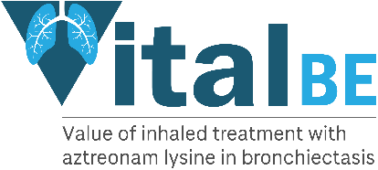
LOCAL NHS LOGO

Email address:

VITAL BE trial
Value of inhaled treatment with Aztreonam lysine in bronchiectasis

Dear Colleague,

Your patient has kindly consented to join the VITAL BE Trial.

Patient details
Name: ____________________________________________________________
DOB: ____________________________________________________________

Address: _______________________________________
_______________________________________
_______________________________________

The VITAL BE TRIAL is a multi-centre randomised placebo-controlled trial of the inhaled antibiotic, Aztreonam lysine, in patients with bronchiectasis. This drug is currently used to treat Pseudomonas infections in patients with cystic fibrosis but is not licensed for use in patients who have bronchiectasis.

Seventy- seven patients with bronchiectasis who grow Pseudomonas aeruginosa in their sputum will be enrolled. Patients will be randomized to receive either active drug or placebo three doses/day. Patients and assessors will be blind to the nature of the therapy. Patients will be trained how to take the drug using a nebulizer. They will take one month’s supply, followed by one month off drug and repeat for 12 months.

We will assess the safety and tolerability of this treatment together with time to first exacerbation and the number of exacerbations during the period of the trial. We will also assess quality of life using validated questionnaires, lung function and bacterial load. Patients will be seen prior to beginning their medication, with follow up phone calls at one and three months, and then with in person visits at six and twelve months afterwards. They will also be seen if they have any exacerbations between these visits.

During the 12 month trial period we ask you not to prescribe medications which are likely to result in changes to the time to first pulmonary exacerbation.
Please do not prescribe the following medications:

- Inhaled antipseudomonal antibiotics
- Long-term macrolides unless these are part of the patient’s treatment regimen prior to joining the study
- Inhaled mucoactive drugs unless these are part of the patient’s treatment regimen prior to joining the study
- Long term antibiotic therapy. Antibiotics may be administered for treatment of an acute exacerbation.

If any significant clinical findings are found during your patient’s participation in this study, you will be informed of the results and any relevant corrective action implemented by myself or medical colleagues.

If you have any questions, please do not hesitate to contact me.
Thank you for your assistance.
With kind regards,

[PI name]
[PI tel]
PI email]

