Tay Estuary Forum Annual Conference 2015
Sustainable Coasts: A Balancing Act
Friday 24th April
West Park Conference Centre, Perth Road, Dundee
9:30-10:00 registration  10am START  4pm FINISH |  | £60. (includes lunch, morning & afternoon coffee & refreshments)  £30. Students
Please return your completed booking form ASAP and by 15th April

- Cheques should be made payable to: University of Dundee, and forwarded to:
Tay Estuary Forum, Room G35, Tower Building, University of Dundee, Dundee, DD1 4HN
- Invoices can be provided on request
- Payment should be made before the conference please
- No refunds shall be given for cancellations less than two weeks before the event
West Park Conference Centre directions and parking info: http://www.westpark.co.uk/how-to-find-west-park
For further details please contact: Laura Booth ( TEF Project Officer)

t 01382 384933 e TayEstuaryForum@dundee.ac.uk w www.tayestuary.org.uk/
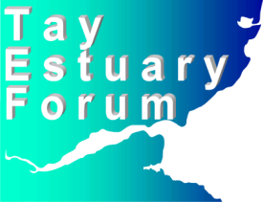
Booking Form
Tay Estuary Forum Annual Conference 2015 – Friday 24th April

Name Organisation

Address

Email

Fax
□ I will be attending for a fee of £60. Student (please attach photocopied proof of status)
[Type a quote from the document or the summary of an interesting point. You can position the text box anywhere in the document. Use the Drawing Tools tab to change the formatting of the pull quote text box.]

No. of places....... Total amount payable £ ............ Invoice required: Yes/ No

Any special dietary requirements

Please return completed booking form, via e-mail to: TayEstuaryForum@dundee.ac.uk
Or print & post to:
Tay Estuary Forum,
Room G35, Tower Building, University of Dundee, Dundee, DD1 4HN
Cheques should be made payable to University of Dundee

