Older People’s Health and Wellbeing Workstream

The Data Driven Quality Improvement in Primary Care study (DQIP2) 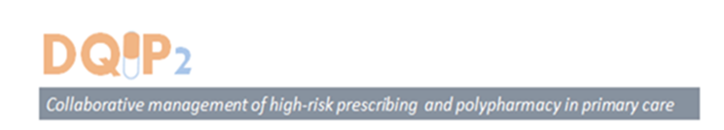

Overview
It is estimated that 3% to 4% of all unplanned hospital admissions, are caused by a preventable adverse drug events; of which two thirds can be associated with high risk prescribing or monitoring.

Harm caused from medicines is an internationally recognised problem. There is a clear link between polypharmacy (i.e. prescription of more than 10 medicines) and the increased risk of an adverse event, e.g. one that can cause harm to the patient and potentially lead to hospital admission. The rising prevalence of multimorbidity and polypharmacy increases the demand for effective medication management services in order to avoid preventable drug related harm and cost.

For a range of reasons older people are more at risk from serious drug related harm. In Scotland it’s estimated that 1 in 5 adults in Scotland are dispensed 5 or more medicines and this rises to 59% in patients over the age of 70 (source http://ihub.scot/media/1037/spsp-medicines-infographic.pdf). This demonstrates the scale of the problem and the potential for improvement in health and wellbeing.

The DQIP pilot study highlighted a substantial variation in high-risk prescribing and that polypharmacy is an important risk factor for high-risk prescribing, especially with an increasing prevalence of polypharmacy. The pilot demonstrated that the combination of an IT tool to facilitate the identification of patients at risk for review, financial incentives and education can significantly reduced high-risk prescribing of non-steroidal anti-inflammatory drugs and antiplatelets and consequently reduce the number of emergency hospital admissions related to the prescribing of these high risk drugs.

Our current focus
The aim of this project is to build on the positive preliminary results from the pilot. Through the stages of this research, we aim to develop, implement and evaluate a pharmacist-mediated and IT facilitated intervention to manage high-risk prescribing and monitoring in primary care.

It is anticipated that improved systems for identifying and managing high-risk polypharmacy will substantially reduce preventable drug adverse effects, including drug related hospital admissions, which account for up to 4% of all emergency hospital admissions in the UK.

