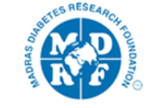
Wednesday 28th October

Time: UK | Introduction | Time: India
10.30 am | Prof. C Palmer & Dr. V Mohan | 4pm
 | Presentations
10.45 am | Lakshmi Karthikeyan  "Secular trends in prevalence of diabetes, prediabetes and its association with lifestyle factors in a rural south Indian population" | 4.15 pm
11.15 am | Charvi Nangia  'Selection Pressures on the ACE2 Gene.' | 4.45 pm
11.45 am | Jyothsna Divyananda  “Predicting the temporal evolution of patient parameters in a diabetic population using Recurrent Neural Networks” | 5.15 pm
12.15 pm | Comfort break | 5.45 pm
12.30 pm | Aravind Lathika Rajendrakumar  “Neutrophil lymphocyte ratio as a Predictor of diabetic retinopathy Incidence in the Scottish population” | 6 pm
1 pm  1.10 pm | Sneha Janaki – “From GWAS to Functional Studies in the South Indian Population”  Yogaprabhu - “From GWAS to Functional Studies in the South Indian Population” | 6.30 pm  6.40 pm
1.20-1.30 | Closing remarks | 6.50-7pm

