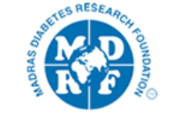

Tuesday 20th October

Time: UK | Introduction | Time: India
11.30 am | Prof C. Palmer & Dr. V. Mohan | 4pm
 | Presentations
11.45 am | Mehul Chourasia  'Heterogeneity in genetic architecture for HDL- Cholesterol levels between Scottish and South Indian population with type 2 diabetes' | 4.15 pm
12.15 pm | Gittu George  ‘PheGWAS - The intelligent cube of possibilities in action’ | 4.45 pm
12.45pm | Mohammad Ghouse Syed  'Estimating clinical parameters and risk factors from retinal images using deep learning in GoDARTS bio-resources'. | 5.15 pm
1.15 pm | Comfort break | 5.45 pm
1.30 pm | Sushrima Gan  ‘A Comparative study on response to DPP 4i, SU and TZD among White Europeans and Asian Indians’ | 6 pm
2 pm | Anand TN Nair  ‘Phenotypic and genotypic determinants of glycemic deterioration in South Indian T2D population’ | 6.30 pm
2.30 pm | Aditya Nar  ‘Comparing Asian and Scottish retinal vasculature’ | 7 pm
3-3.30pm | Closing remarks | 7.30-8pm

