Workshop Proposal Title. Subtitle

First name Last nameª, First name Last name^{b}, First name Last name*
ªAffiliation name
^{b}Affiliation name
*Corresponding author e-mail:
Abstract:
These guidelines provide instructions to format your Workshop Proposal for the 13th European Academy of Design Conference, ‘Running with Scissors’. Please write directly into the template or copy your finished text into it choosing ‘match destination formatting’. Please use the predefined formatting Styles, preceded with ‘_RwS’: such as _RwS Proposal Title, _RwS Paragraph or _RwS Picture. Do not change the predefined formatting settings in this document as the aim is to produce the conference proceedings using a consistent style. The Abstract should be no more than 150 words and one paragraph only. Please follow the template outline below to provide all of the necessary information requested. Proposals should be submitted to the Conference management system at: https://www.conftool.org/ead2019/ by 10th December 2018
[STYLE: _RwS Abstract]

Keywords: maximum 4 keywords; paper format; instructions; use of template

General Guidelines
In order to include all the information required for the workshop please complete Sections 1-6 below. The General Guidelines here provide additional information for you as a Workshop Organiser and can be removed prior to submitting your revised proposal.
You should submit your proposal in PDF format using this template. There will be a final round of review, and all accepted proposals will be published in the proceedings, assuming that the workshop leaders register to attend the conference and deliver the session. The publication will have an ISSN/ISBN number and a DOI reference to ensure it appears in scholarly web-searches, and will be accessible from the conference website.
This template document itself uses the same formatting as required for the Conference so your proposal should appear visually very similar. You can access template styles for Titles, paragraphs, and other styles directly from the Quick Style Menu that is part of the Home Menu in Word. You can either write directly into the template or paste your finished text into it and choose ‘match destination formatting’ in the pop-up menu that appears when you paste in text. Do not change the predefined formatting settings in this document (such as paper size, orientation, margins, typeface, size, indents, spacing, headings, etc.).
The main text of the submission should be formatted with [STYLE: _RwS Paragraph]
If your proposal requires sub-sections, these should be numbered, though not go deeper than one sub-section (i.e. Section 2.1 is fine but Section 2.2.1 is not - see section 3 for an example).
Any tables required should be formatted in the same way as Table 1 below: left justified text for first column and centred columns thereafter, if possible. Only horizontal table grid lines should be used and the table should have the same width as normal text paragraph in order to fit exactly within the document margins. Add one empty paragraph of the [STYLE: _RwS Paragraph] style following a table.
Short quotations within the text should be marked with double quotation marks e.g.: Lawson also has a broad understanding of design when he mentions: “Professional designers such as architects, fashion designers and engineers” (Lawson, 2004, p.5). Longer quotations of more than three lines should be formatted as below, without double quotation marks:
More of the goods and services produced for consumer across a range of sectors can be conceived of as ‘cultural’ goods, in that way they are deliberately inscribed with to generate desire for then amongst the end uses sold to consumers in terms of particular clusters of meaning indicates the increased importance of ‘culture’ to production circulation of a multitude of goods and services. (du Gay, et al, 1997, p.24) [STYLE: _RwS Long quotation]
For lists of material you can either use a bulleted list:
- European; [STYLE: _RwS Bullet list]
- Academy;
- Design.
Or a numbered list:
- Running; [STYLE: _RwS Numbered list]
- With;
- Scissors.

1. Context of Workshop [STYLE: _RwS Heading 1]
Here you should give a short background to your proposed workshop. We are looking for proposals that fit within the theme of the conference and track.

2. Planned Activities and Expected Outcomes
Describe the organisation and activities that your workshop will consist of, and indicate the kind of outcomes that you might expect. What will participants leave your workshop with?

2.1 Images
If your proposal requires sub-sections, these should be numbered, though not go deeper than one sub-section (i.e. Section 3.2 is fine but Section 3.2.1 is not).
Please think carefully about the choice and presentation of your visual material, if included. Please only use photographs, figures or artwork for which you have copyright clearance or permission. Ensure images are credited and cited as appropriate.
Where possible please make images:
- Large enough to see clearly;
- Of good resolution (200dpi);
- Optimised to be less than 350Kb;
- Cropped appropriately.
If you are using diagrams, info graphics, or other schematics please ensure that:
- You present information clearly;
- You use the Calibri font;
- All text is legible;
After you insert an image into your document, select it and use the style named [STYLE: _RwS Picture]. The image should have the same width than the formal paragraph and fit exactly within the document margins if possible and reasonable. Images are followed by a caption with figures numbered sequentially – Figure 1, Figure 2, etc.
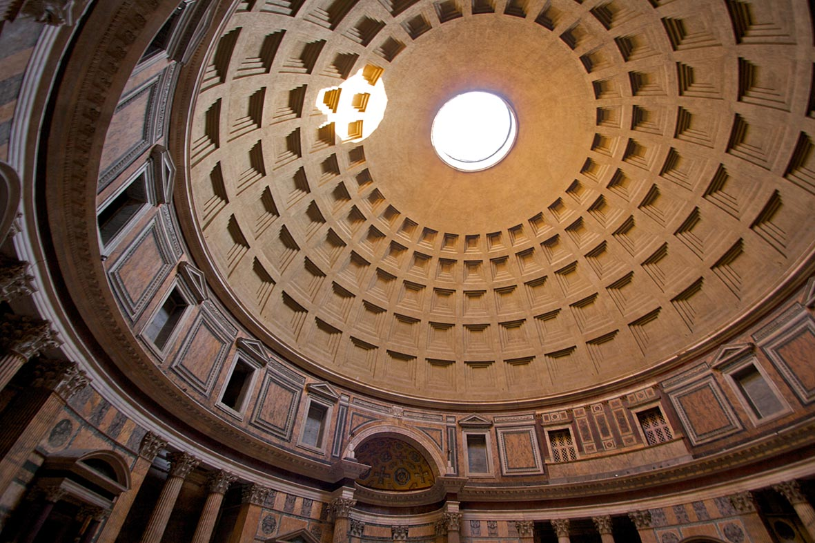
Figure 1. Captions are placed under the pictures. Ensure that your caption adequately describes what you want your reader to see in the picture, highlighting any areas that they should focus on or relationships that you might want them to see. Include image credits. [STYLE: _RwS Caption].

3. Intended Audience

You should include here the intended audience for your workshop. We are looking for proposals that bring together participants from different backgrounds.
Give an indication of the ideal number of workshop participants.

4. Length of Workshop
EAD2019 Workshop sessions are available for 1.5 hours.
Give a short justification for your Workshop length.

5. Space and Equipment Required
We have a range of spaces that are available. Most are studio-like spaces and can be configured in a number of ways, though some are more formal. We’d also like to encourage workshops that engage with the spaces and communities surrounding the conference venues.

6. Potential Outputs
Describe any outputs that may follow from holding your workshop, especially anything that will enhance the impact of the conference in general.

References

Referencing should follow the APA, Author-date, Style Guide as explained in the official guide: http://www.apastyle.org/learn/tutorials/basics-tutorial.aspx (slides 13-25)
If you use reference management software such as EndNote or Word Citation & Bibliography make sure that you submit your proposal with the fields unlinked to your bibliographical database. (Please remove this information prior to submission)

Desmet, P. M. A., & Hekkert, P. (2007). Framework of product experience. International Journal of Design, 1(1), 57-66.
Bergen, D. (2002, Spring). The role of pretend play in children's cognitive development. Early Childhood Research & Practice, 4(1). Retrieved February 1, 2004, from http://ecrp.uiuc.edu/v4n1/bergen.html.
Wundt, W. (1905). Fundamentals of psychology (7th ed.). Liepzig: Engelman.
Schifferstein, H. N. J., Mugge, R., & Hekkert, P. (2004). Designing consumer-product attachment. In D. McDonagh, P. Hekkert, J. Van Erp, & D. Gyi (Eds.), Design and emotion: The experience of everyday things (pp. 327-331). London: Taylor & Francis.
Khalid, H. M. (2001). Can customer needs express affective design? In M. G. Helander, H. M. Khalid, & T. M. Po (Eds.), Proceedings of Affective Human Factors Design (pp. 190-198). London: Asean Academic Press.
Chen, C.-w., You, M., Liu, H., & Lin, H. (2006). A usability evaluation of web map interface. In E. Koningsveld (Ed.), Proceedings of the 16th World Congress of the International Ergonomics Association [CD ROM]. New York: Elsevier Science.
Wu, J. T., & Liu, I. M. (1987). Exploring the phonetic and semantic features of Chinese words (Tech. Rep. No. NSC75 0310 H002-024). Taiwan National Science Council.
Nielsen, M. E. (n.d.). Notable people in psychology of religion. Retrieved August 3, 2001, from http://www.psywww.com/psyrelig/psyrelpr.htm.
Gender and society. (n.d.). Retrieved December 3, 2001, from http://www.trinity.edu/~mkearl/gender.html.
Hien, D., & Honeyman, T. (2000). A closer look at the drug abuse-maternal aggression link. Journal of Interpersonal Violence, 15(5), 503-522. Retrieved May 20, 2000, from ProQuest database.
Lin, R. T. (2006). 訴說故事，營造情境--文化創意設計的情境故事 [Scenario and story-telling approach in cross cultural design]. 藝術欣賞, 2(5), 4-10. [IF THE ORIGINAL ARTICLE IS NOT IN ENGLISH LANGUAGE, IT SHOULD BE TRANSLATED AND INSERTED IN PARENTHESIS, AS INDICATED HERE]
Author (2012). Journal article. [GENERIC REFERENCE TO THE AUTHORS’ OWN WORKS UNTIL FINAL ACCEPTANCE, FULL REFERENCE SHOULD BE INSERTED AFTER THE BLIND REVIEW]
Author (2015). Conference paper. [REFERENCE TO THE AUTHORS’ OWN WORKS UNTIL FINAL ACCEPTANCE, FULL REFERENCE SHOULD BE INSERTED AFTER THE BLIND REVIEW]

About the Organisers:
Organiser 1 add an Organiser bio that describes your background and any other achievements in a maximum of 40 words. [_RwS Author Bio and Acknowledgements]
Organiser 2 add an Organiser bio that describes your background and any other achievements in a maximum of 40 words.
Organiser 3 add an Organiser bio that describes your background and any other achievements in a maximum of 40 words.
Acknowledgements: this section is optional. You can use this section to acknowledge support you have had for your research from your colleagues, student’s participation, internal or external partners’ contribution or funding bodies.

