|  |
| --- |
| PARTICIPANT INFORMATION SHEET – Sub Study |

**AIR-NET Tayside sub-study: assessment of blood vessel function in people with bronchiectasis**

# Chief Investigator

Professor James Chalmers

# Why have I been contacted?

You have agreed to take part in the AIR-NET trial. In Tayside we are also doing an optional sub-study to look at blood vessel health in people with bronchiectasis. Please read this information sheet and decide if you would also like to take part in the additional sub-study.

If you do not want to take part in the sub-study, you can still take part in the main trial.

# Why are we doing this sub-study?

Our research has found that people with bronchiectasis are more at risk of blood vessel diseases, such as a heart attack or stroke.

We will do extra assessments to measure different markers of blood vessel health. The main objective of the sub-study is to see if whether treatment for bronchiectasis affects the function of blood vessels.

The blood vessel assessments are:

**Pulse wave velocity (PWV):**

This measures how elastic (springy) your blood vessels are. We’ll put a blood pressure cuff on your arm and thigh and then measure your blood pressure and pulse. We’ll measure your pulse by placing a small probe (similar size to a pencil) on your skin.

**Iontophoresis & full-field laser perfusion imaging (FLPI):**

This measures blood flow and circulation in your skin. We will apply two chemicals to the skin on your arm. We do this by taping two small chambers to your skin, the chemicals will travel between the chambers over the skin after applying a small electrical current. We will apply Acetylcholine and Sodium nitroprusside which relaxes your blood vessels (vasodilation). We will use laser imaging to measure the blood flow in the skin. This tells us how your blood vessels respond to the chemicals. You will not feel any discomfort during this test. These chemicals only act over the skin with no overall effects on your body.

The test set up will look like this:

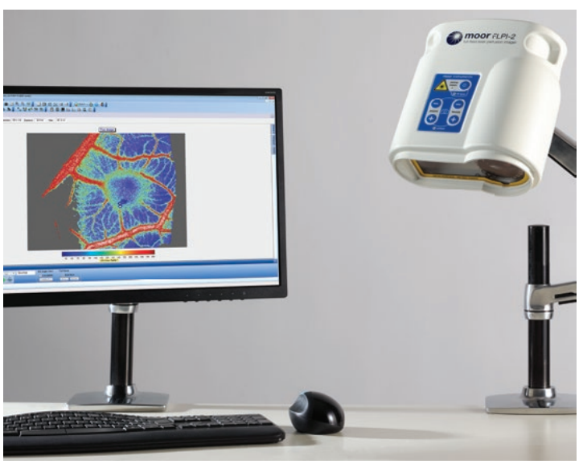

# Waist and Hip measurements:

# The ratio of these measurements are useful predictors of heart attacks and strokes. We would like to analyse this information along with PWV and FLPI.

# What will happen to me if I take part?

You’ll receive these additional assessments after the regular study assessments with no extra visits needed. These additional assessments are non-invasive and will take approximately 2 hours

Visit 2:

* Waist and hip measurement
* PWV
* FLPI

Visit 5 & 6:

* PWV
* FLPI

# Do I have to take part?

No, taking part in the sub-study in optional and entirely your choice. You can still take part in the AIR-NET trial without taking part in this sub-study.

**What are the possible benefits of taking part?**

Your health will be monitored closely during the trial by the trial team. If any medical findings are identified, these will be discussed with you and your medical care provider. The results of this study may help how we treat people with bronchiectasis in the future.

# What are the possible disadvantages and risks of taking part?

All the sub-study assessments are non-invasive however you might experience some discomfort when blood pressure cuff is inflated. In some cases, participants may experience mild itch or skin irritation which lasts for a few hours. The skin reaction does not lead to any permanent disruption to the appearance or function of the skin.

# Who is organising and funding this research?

This trial is being sponsored by the University of Dundee and NHS Tayside. It is being funded by LifeArc, a medical research charity. The trial is being organised by Professor James Chalmers.

Who has reviewed this trial?

This sub-study has been reviewed by London – Central Research Ethics Committee.

|  |  |  |  |  |  |  |
| --- | --- | --- | --- | --- | --- | --- |
| AIR-NET Sub Study Trial Assessments | Visit 1 | Visit 2 | Visit 3 | Visit 4 | Visit 5 | Visit 6 |
| Pulse wave velocity (PWV) |  | X |  |  | X | X |
| Iontophoresis and full-field laser perfusion imaging (FLPI) |  | X |  |  | X | X |
| Waist & Hip measurements |  | X |  |  |  |  |